**Sorting**

Name: Poreddi Rohith Reddy

Question: **Python program that can take different numbers of string and then sort them**

**Rule of Sorting:** I have applied bubble sorting technique to sort the strings list in ascending order.

**Description:**

* Used an interactive algorithm that allows the user to input the number of strings.

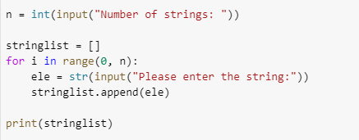

* Defined a function called sort which accepts string list as parameters, the string with the least length will be displayed first and next least length will be displayed second. This way it sorts all the strings in the list in the ascending order.

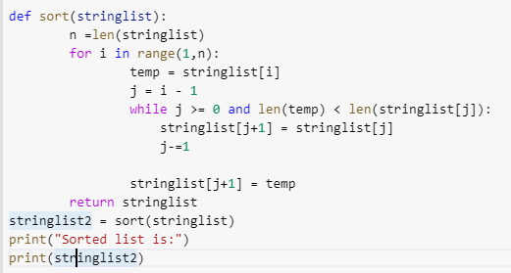

* After user has given the number of strings, the program allows the user to enter a string by throwing a statement : “Please enter the string”
* Once the user has entered all the desired strings, the list of strings will be displayed and next the sorted list result will be displayed.

Here are a few test cases that will satisfy the above program

**Test Case-1: Sorting with 4 different strings**

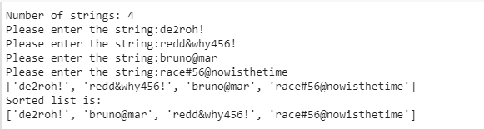

**Test case-2: Sorting with 5 different strings**

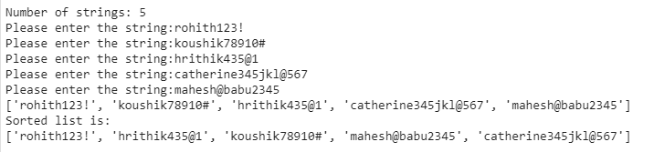

**Test case-3: Sorting with 6 different strings**

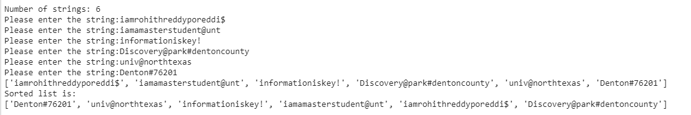

**Test case-4: Sorting with 7 different strings**

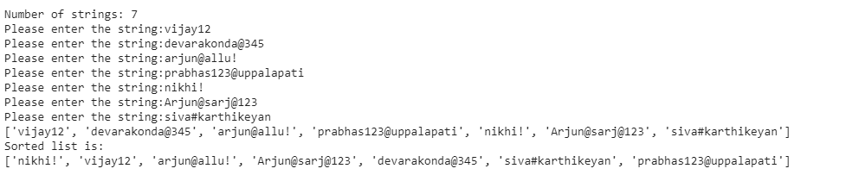

**Test case-5: Sorting with 8 different strings**

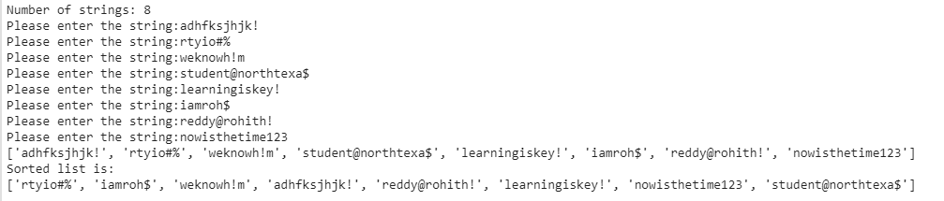

**Visualization:**

* I have used matplot lib and seaborn to visualize the length of the strings and used a random generator to generate different lengths of strings.
* I have set the minimum length of the string to 5 and maximum length to 50 and generated 500 strings between these lengths.

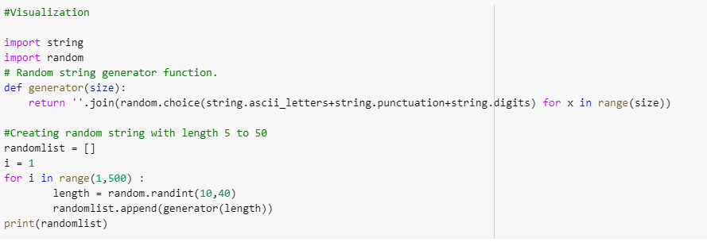

**Scatter plot:** I have taken x-axis as length of the string and y axis as order of the string

